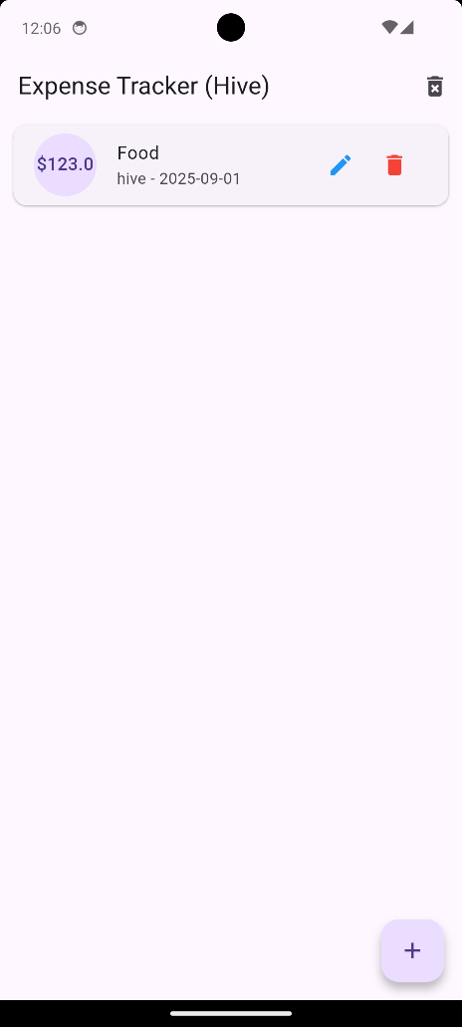Hive

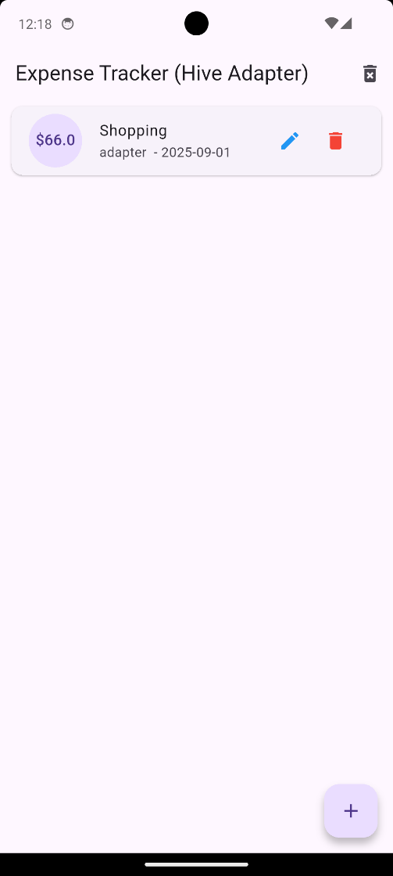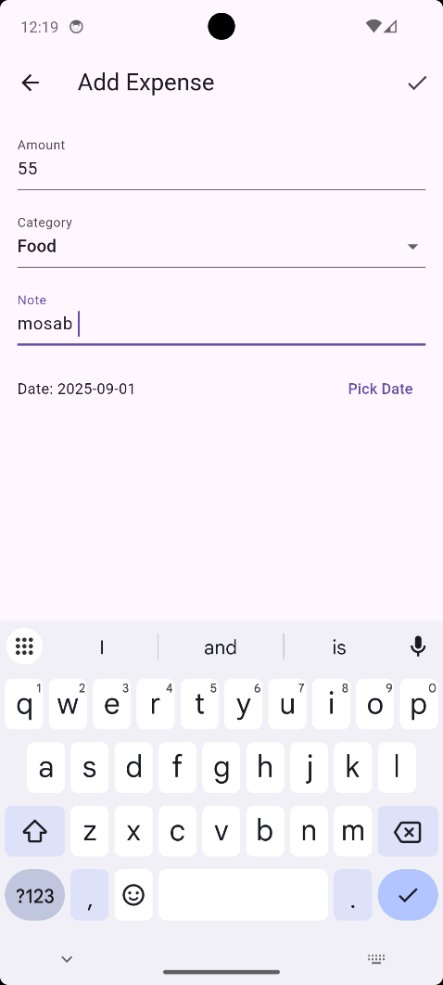Hive Adapter

